**Brief Introduction about Cloud Computing**

**Definition of Cloud Computing:**

Cloud computing is the **delivery of computing services over the internet** on a **pay-as-you-go** basis. These services include storage, processing power, databases, software, and networking, without the user needing to manage physical infrastructure.

**Types of Cloud Computing (Deployment Models):**

1. **Public Cloud** – Services provided over the internet by third parties (e.g., AWS, Azure, Google Cloud).
2. **Private Cloud** – Exclusive use by one organization, often on-premises.
3. **Hybrid Cloud** – Combination of public and private for flexibility.
4. **Community Cloud** – Shared by organizations with similar requirements (e.g., government bodies).

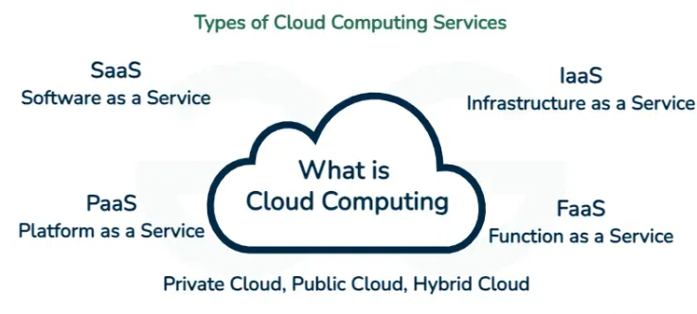

**Cloud Service Models (Layers of Service):**

| **Model** | **Description** | **User Manages** | **Example** |
| --- | --- | --- | --- |
| **IaaS** (Infrastructure as a Service) | Provides virtualized computing resources like VMs, storage, networks. | OS, apps, data | AWS EC2, Azure VM |
| **PaaS** (Platform as a Service) | Provides a platform to develop, run, and manage applications. | Apps, data | Google App Engine, Azure App Service |
| **SaaS** (Software as a Service) | Fully managed applications accessible over the internet. | Just use it | Gmail, Dropbox, Salesforce |
| **FaaS** (Function as a Service) | Serverless computing where code runs in response to events. | Just the function code | AWS Lambda, Azure Functions |
|  |  |  |  |

**Cloud Computing Architecture:**

**1. Front-End (Client Side)**

* Web browser or client application
* User interface for accessing cloud resources

**2. Back-End (Cloud Provider Side)**

Includes the major building blocks:

* **Infrastructure** – Servers, storage, networking
* **Services** – SaaS, PaaS, IaaS, FaaS
* **Management Software** – Monitors and controls resource usage
* **Security Layer** – Authenticates users and protects data